**The First Reign of Darcy.**

After some days travel we have arrived at “Groovedbridge”. There is a brook; there are trees, plants and a mountainside full of stone, gems and ore. This seems as though it will make a fine home for our dwarves. I’ve decided to have the miners begin digging out a fortress with a channel running through the fortress so there will be running water and a fountain in the center (once some pumps are built and some channels dug).

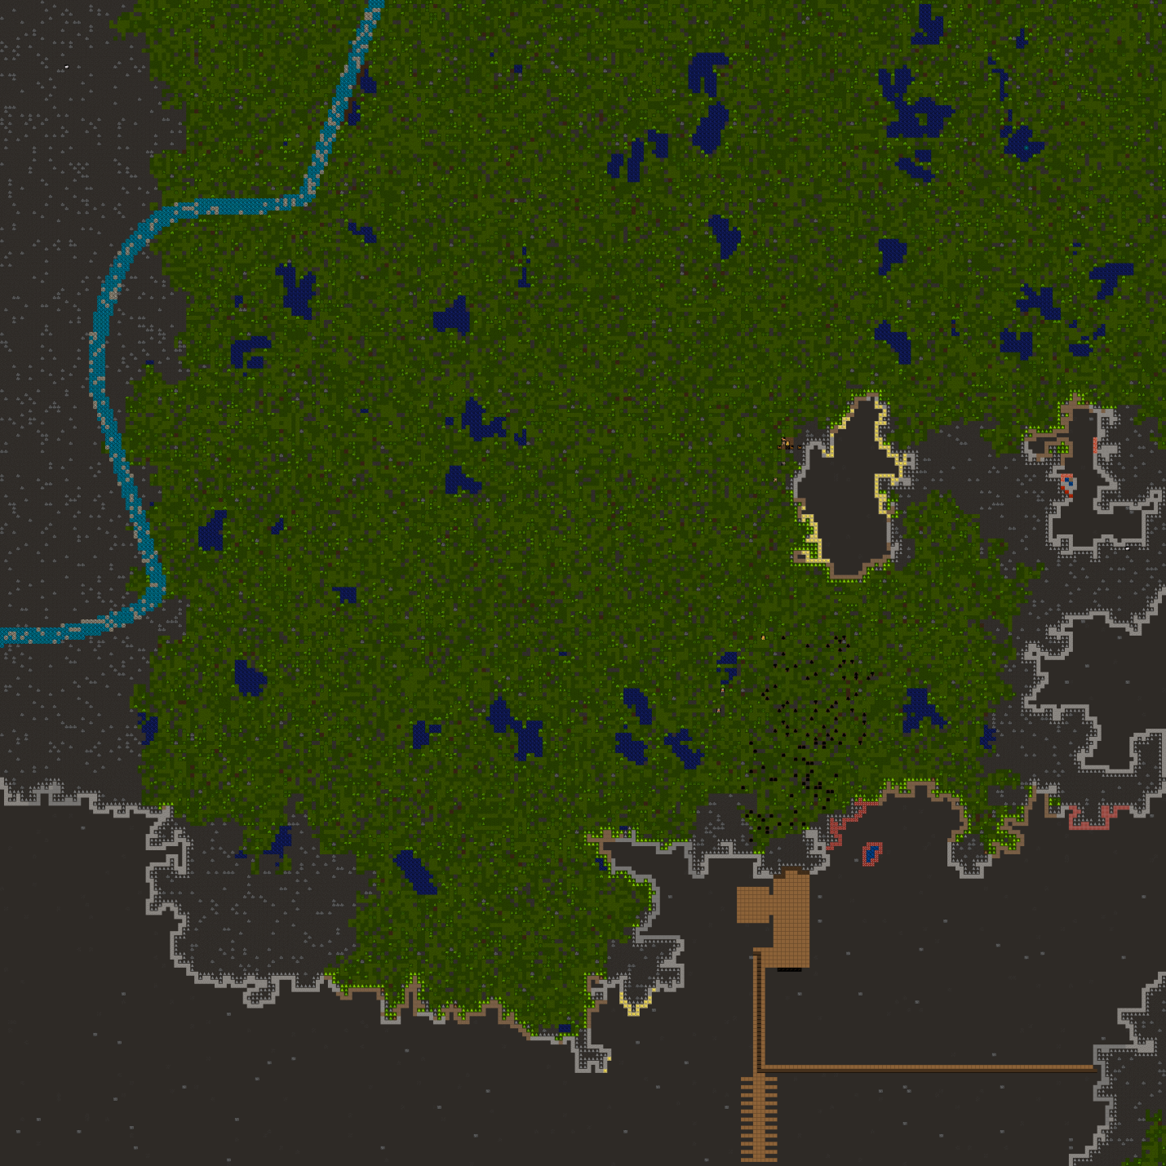

And, as luck would have it, before the entrance could even be finished a dwarf found that life in the sun was too much for him.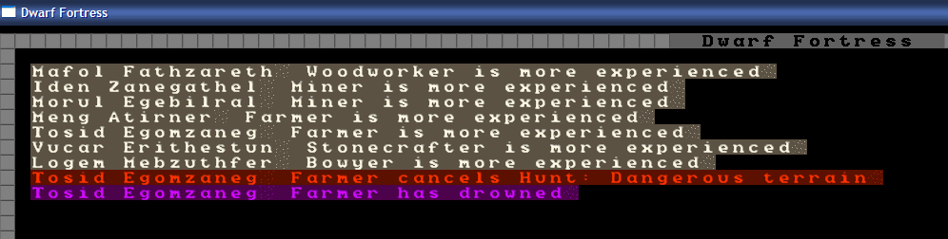

The highly skilled cook, brewer, hunter, trapper, farmer fell into a pool of water while chasing deer.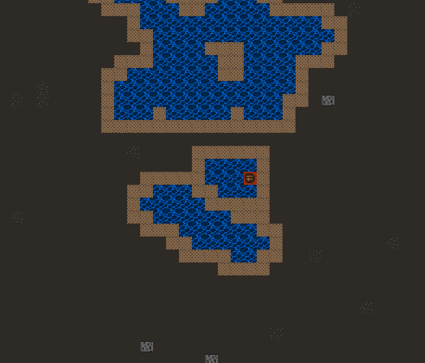

Well… that was quick wasn’t it… and now there is going to be the issue of training a cook, farmer, etc. in the future. Why this happened I’m not 100% sure but I have suspicions of pointy eared demons.

After some time the entrance has been completed, as well as some minor workshops. This has been slow going for even the experienced minors as the stone is, well… hard. 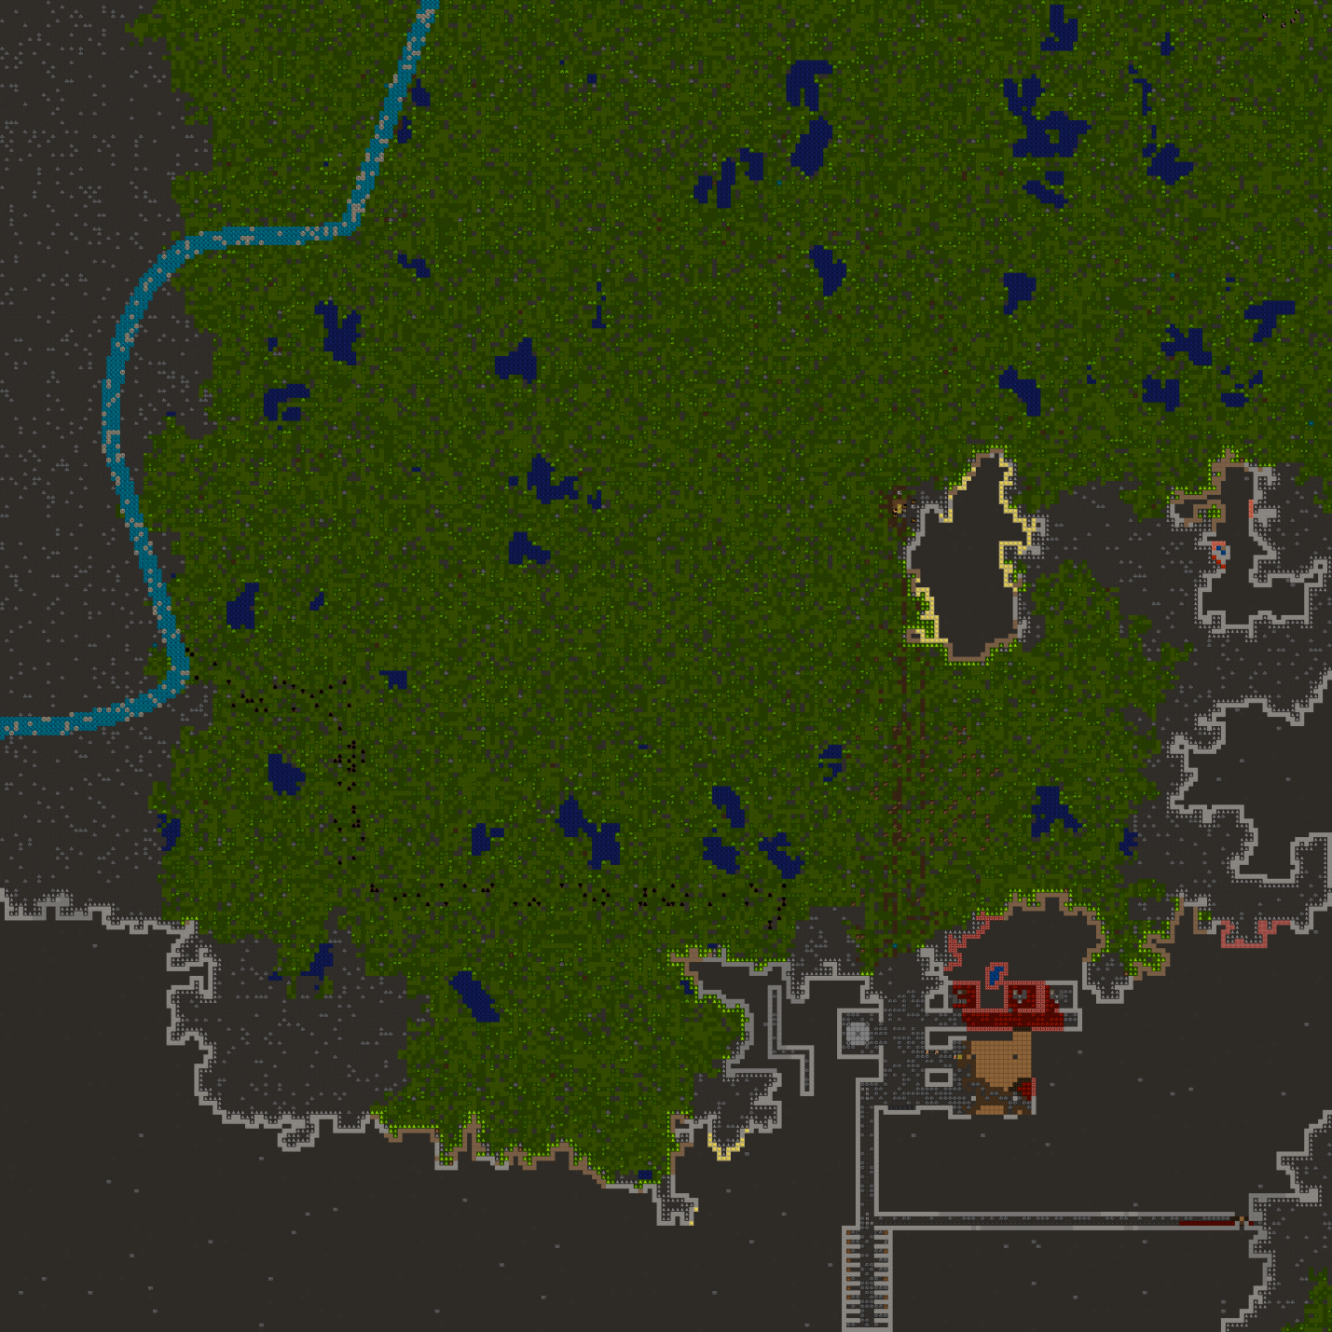

There is a trade depot built, a carpenters workshop and two mason’s workshops. Work is currently being done to construct a dining room. There is also a barracks built for the dwarves to sleep in and the beginning of my elaborate plans to channel the brook to the fortress and down through it and out the other side, with the help of pumps and windmills. I’ve also been trying my hardest to get all that blasted stone off the floor and out of the fortress so I’ve started putting it on the mountainside above the fortress.

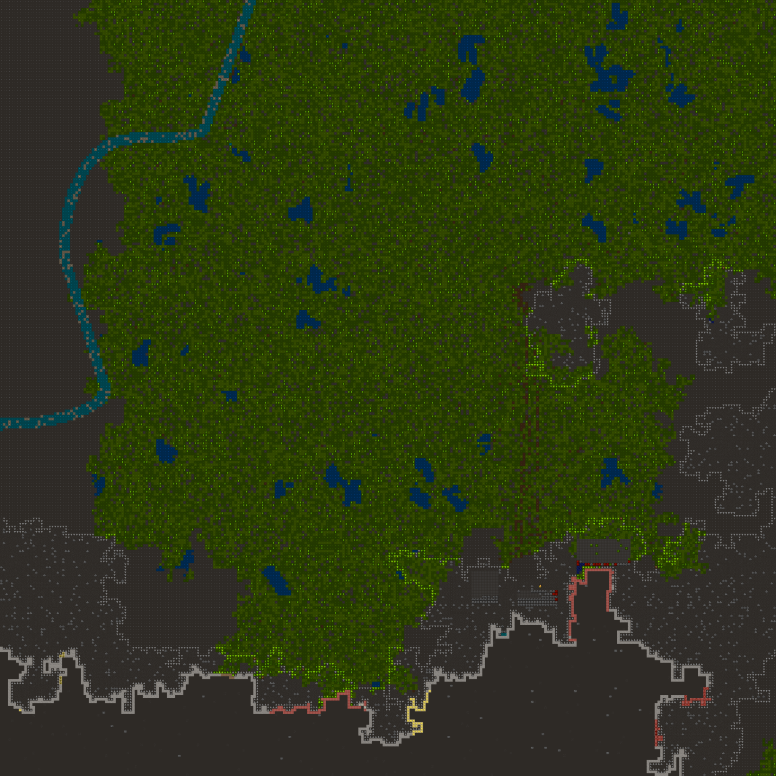

No massive hiccups thus far. Rubies have been found in the stone of the future dining room and a little more mining has been done for a food stockpile, a wood stockpile and two craftdwarf workshops… although perhaps a little too late.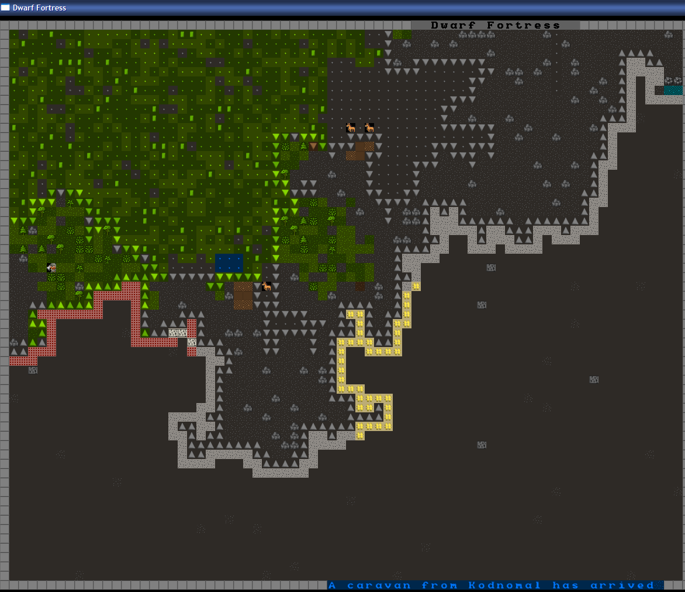

A caravan! Awesome, except I still don’t have anything to trade with them. Well, at least their caravans can get to me. I started franticly making stone crafts to trade, although I was too late. Still, they’ve mentioned some things that they would like in the future:

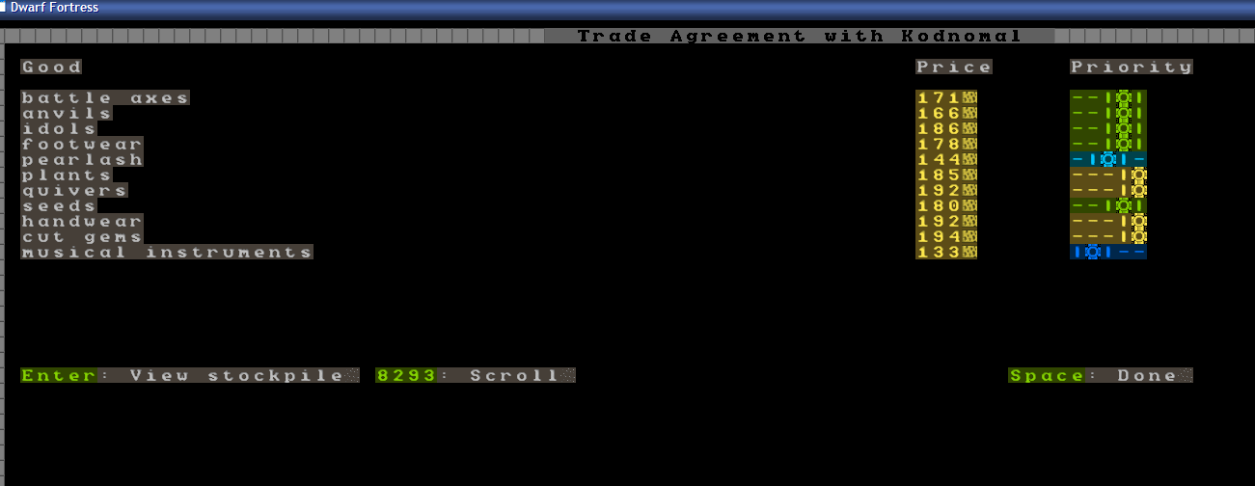

Gems? I can manage that. Plants, quivers and handwear I’m a little further off having to spare.



That was a pity but there is still plenty of food and booze so the fortress should be fine without their goods, for now. So let’s look at the new changes: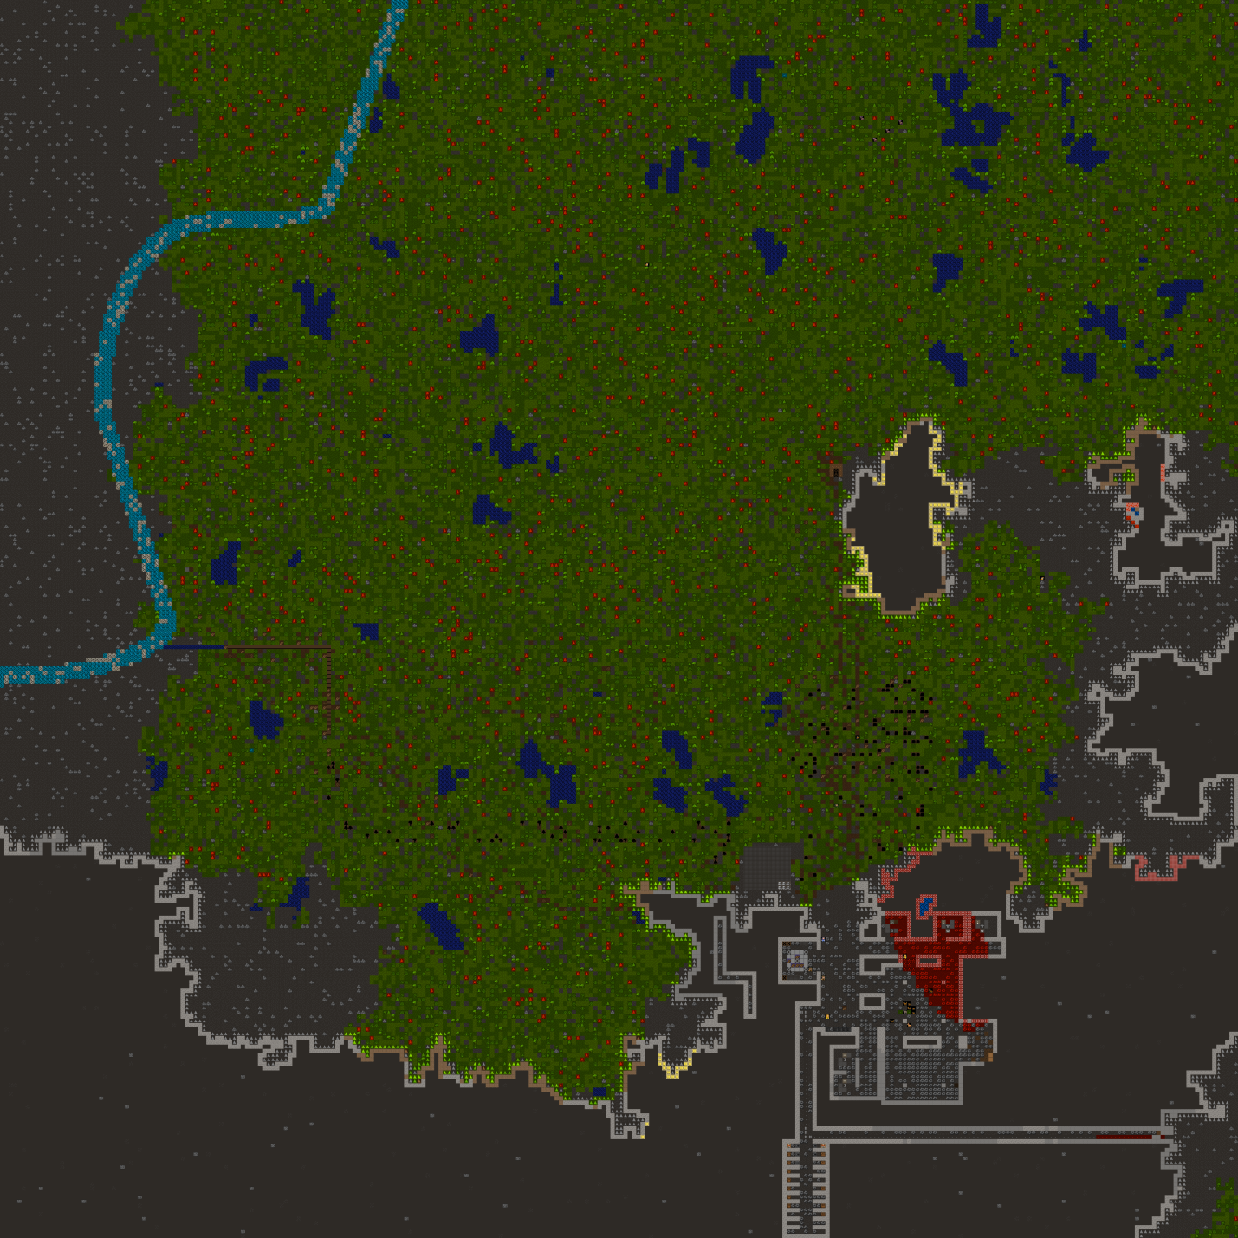

Not too shabby and just in time…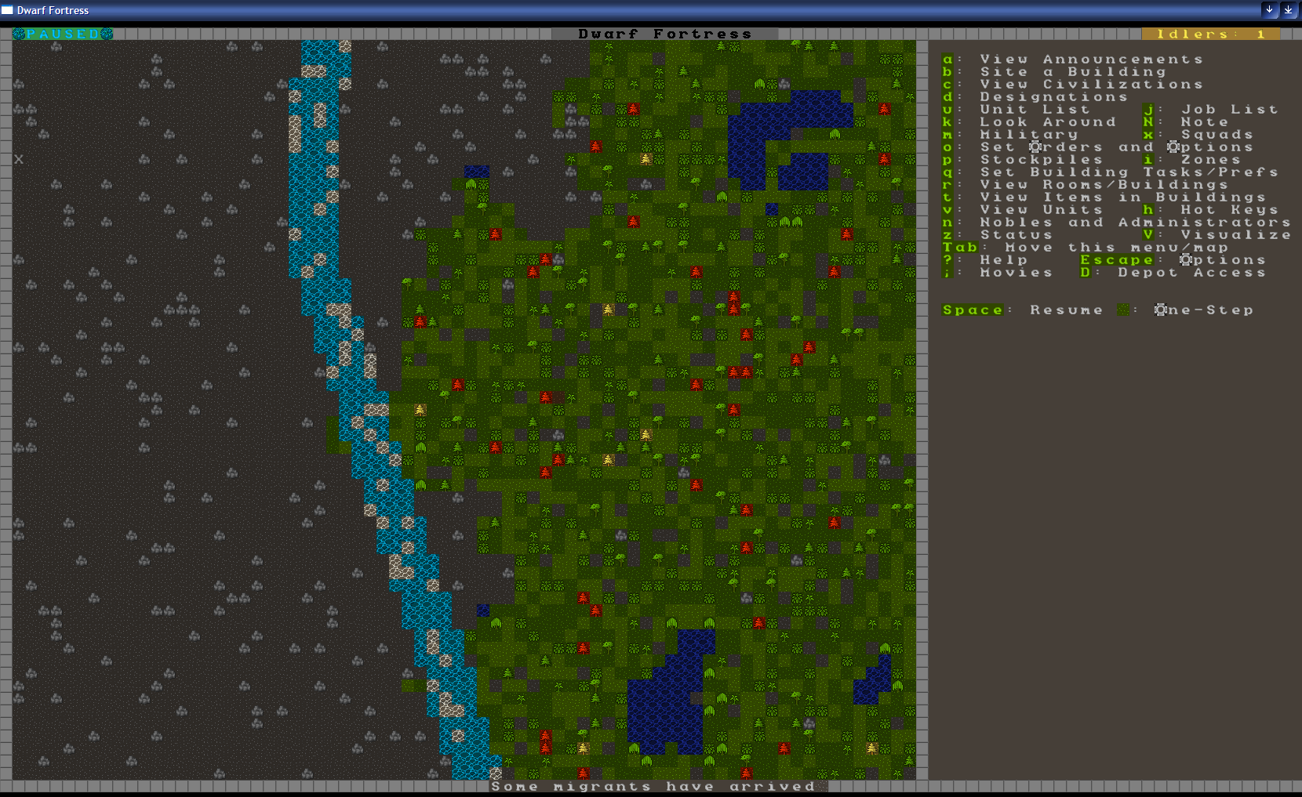

Yay, Migrants! Shared work makes the inevitable sudden loss of a dwarf less of a disaster. There are so many new faces with so many interesting, yet irrelevant skills to offer my fortress. I’ve given them all random jobs to fit their new home and set them to work. Wait! What’s this?

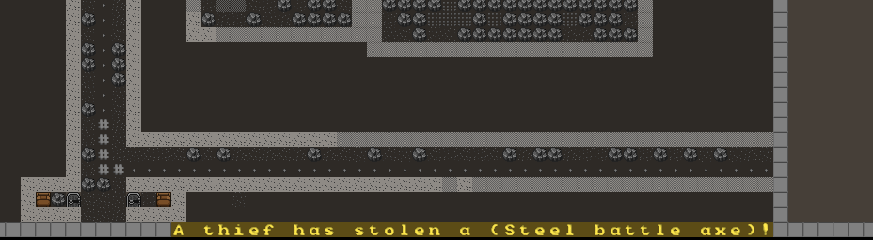

Damn it! Now that one thief has gotten away with stealing one thing there will surely be more in the future. This is because there are still some goods outside. I’d had better move them inside with new stockpiles. I’ve also gotten more stone out of the fortress and started cooking and brewing in the new kitchen and still.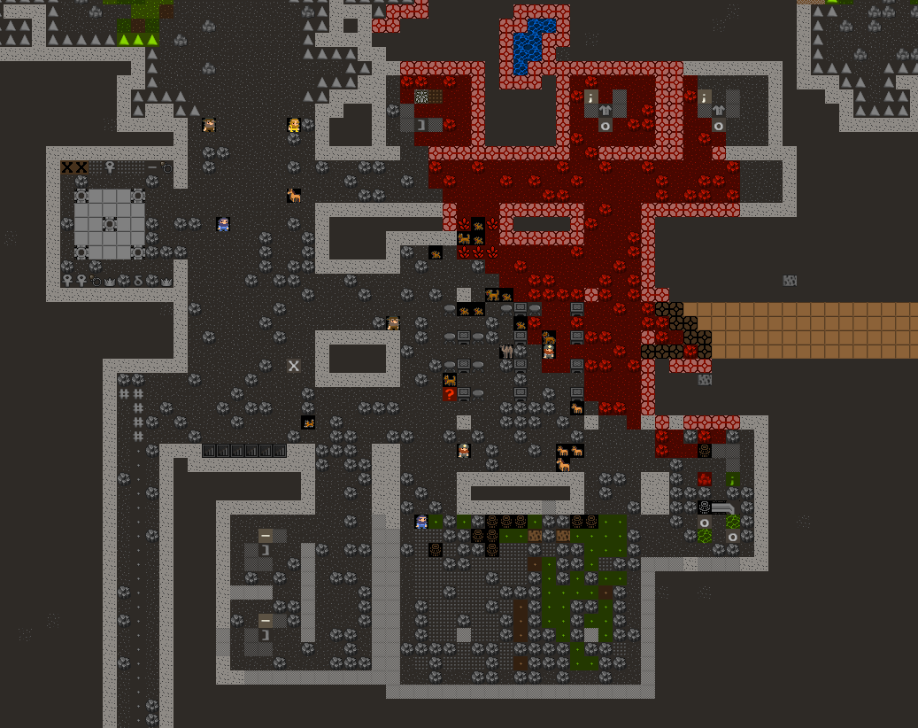

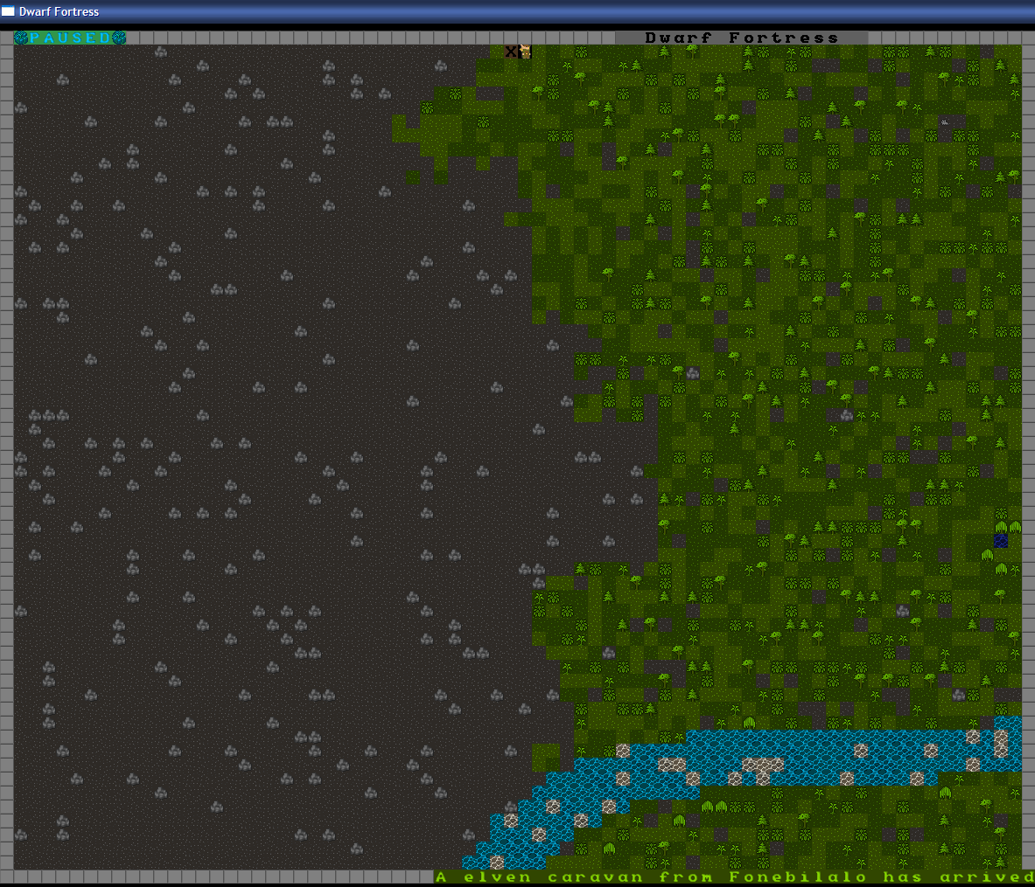

Yes! An elven caravan has shown up, and I have non-wood goods to trade with them. I hope they like stone and bone. I’ve moved my bins full of goods to the trade depot for trading with the elves. I’m intending to trade for more booze. What? They won’t trade with us? Murderers? What the hell are these elves talking about…? I’m trading only stone and bone goods in these wooden bins… oh god fucking damn it. Apparently I forgot that the finished good bins where made of wood.

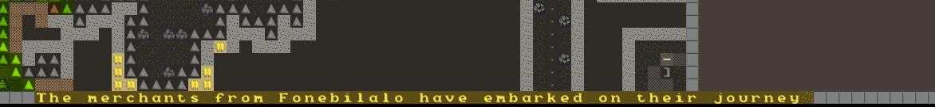

Doesn’t look like I’ll be trading with the elves today… pointy eared fuckwits.

Well, it looks like food and booze production is happening as well as crafts for trade. Those where my 3 big goals after I had the basics built so I’ll hand this on. I hope the next player can finish my water channel/fountain as well as starting some farming and building some fortress defences.

Good luck.